Unit 1 : Number Relationships within 30
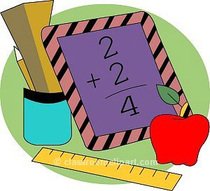
1st grade Math
2014-2015

Dear 1st grade families,
Welcome back to school! What an exciting time to be in 1st grade! We will be learning many new concepts this year and will see lots of new strategies to help us become mathematically proficient students as we implement the Common Core State Standards for Mathematics. This overview will be coming with each new unit of study to let you know at home what we will be learning in school and how you can help support your child at home.
Unit Vocabulary :
after before
compare digits
dime decreasing
expanded form equation
expression even
equal greater than
increasing longs/rods
less than model
more number number sentence numeral number line nickel
order ones place odd place value penny quarter quantities represent standard form skip count sequence tens place

Unit Summary :

Students will work to proficiency with numbers 0-30. Students will orally count, write and read numbers from 0-30. They will represent a set of objects with written numerals and representations using base ten blocks and ten frames. Students will count by 1’s, 2’s, and 10’s and be proficient in doing so from any number. In identifying sets of objects, students will compare multiple sets as more or less and apply such skills to interpreting graphs using how many more, how many less.

Essential Skills:
- Counting 0 to 30 forwards and backwards.
- Read, write and represent numbers and sets with words, numerals and models
- Number lines & Number charts
- Skip counting by 2s
- Comparing numbers and sets as more or less
- Reading graphs and charts

Activities to try at home :

- Count everything! As children set the table or clean up toys, have them count what they are using aloud.
- Create a counting book with pictures from the newspaper or magazines. Have your child label the pages of the book with the number of items in the pictures.
- Play “Guess my Number” Think of a number between 0 and 30 and let your child try to guess the number by asking questions.
- Play Number War. Use a deck of cards without face cards. Each player deals out 1 card. The player with the larger amount, takes both cards until one player has captured all the cards.

Additional Resources :

Suggested Books to read together :

Mother Goose Numbers on the Loose By Leo and Diane Dillon
Anno’s Counting Book By Mitsumasa Anno
Olivia Counts By Ian Falconer
One Was Johnny: A Counting Book By Maurice Sendak
Mouse Count By Ellen Stoll Walsh

Websites to visit :
- PBS kids : http://pbskids.org/lab/news/
- Counting games : http://www.kidsmathgamesonline.com/counting.html
- Crickweb : http://www.crickweb.co.uk/Early-Years.html
- Math Playground : http://www.mathplayground.com/index.html

