**Unit 2 : Early Addition & Subtraction**

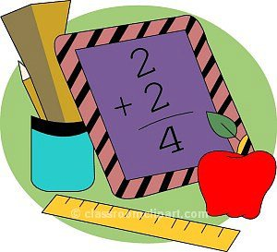

1st grade Math

***Essential Skills:***

* Add and subtract with word problems.
* Explore properties of addition and subtraction.
* Addition facts within 10
* Subtraction facts within 10.
* Understand the meaning of “=” symbol.
* Using counting strategies to help add or subtract.

***Unit Summary:***

Students will work to apply their knowledge of counting and relate it to addition and subtraction. Students will begin to identify addition as join and subtraction as take away utilizing many tools to help them solve accurately. In regards to addition, students will be proficient in fluently adding numbers with sums up to 10. In regards to subtraction, students will be proficient in fluently subtracting with numbers 0-10. Students will begin to understand the relation of addition and subtraction through fact families. Students will also analyze number sentences to determine if an equation is balanced based on the meaning of = as “same as”. Students will apply their knowledge of addition and subtraction and persevere while solving word problems.

***Unit Vocabulary:***

add, addition, apply, ascending, count back, count on, descending, difference, double, equal, equation, explain, expression, fact family, fewer, interpret, join, least, less, make 10, more, most, number sentence, open number line, operation, part, perseverance, same as, strategy, subtract, subtraction, sum, take away, ten frame, tools, whole

***Additional Resources :***

*Books to read:*

* ***Mouse Count,*** by Ellen Stoll Walsh
* ***Ten Sly Piranhas,*** by William Wise
* ***Counting Crocodiles,*** by Judy Sierra
* ***Teeth, Tails and Tentacles,*** by Christopher Wormell

*Websites to visit :*

* Learning to Add & Subtract : <http://www.pitara.com/activities/math/algebra/index.asp>
* Addition Practice : <http://www.fun4thebrain.com/addition.html>
* Subtraction Practice: <http://www.fun4thebrain.com/subtraction.html>
* Counting/Operations Practice : <http://www.primarygames.com/math.php>
* Dr. Mike’s Math games for first grade: <http://www.dr-mikes-math-games-for-kids.com/first-grade-math-games.html>

