Unit 5: Non-Standard Measurement
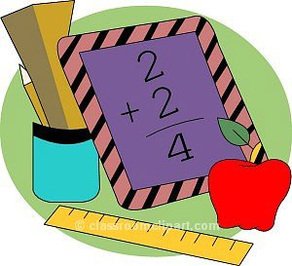
1st grade Math

Unit Summary :

During this unit, students will develop an understanding of measurement. They will explore measuring the length, height and width of objects and compare the lengths of objects when you can put them side by side or using another object to compare the lengths of two objects. The students will use non-standard units such as paper clips, connecting cubes or color tiles to measure the length of an object and then compare up to 3 objects to place them in order.

Essential Skills:

- Measure length, height and width with non-standard units.
- Recognize when an object is longer or shorter than another object.
- Compare and organize three objects by length in order from shortest to longest.
- Explain how to use a shorter object to measure the length of a longer object
- Explain why it is important to avoid gaps and overlaps.
- Represent the length of the longer object with a whole number.

Unit Vocabulary :

compare crooked
different fold
half height
length longer
longest measure
non-standard order
same shorter
shortest straight
taller tallest
tool unit

Additional Resources :

Online activities for practice:
- Clifford’s Measuring Up : http://pbskids.org/clifford/games/measuring_up.html
- Curious George’s How Tall? : http://pbskids.org/curiousgeorge/games/how_tall/how_tall.html

Books to read :
- Measuring Penny by Loreen Leedy
- How Big is a Foot? by Rolf Myller
- The Best Bug Parade by Stuart Murphy

Activities to try at home :

- Have your child measure the length of an object by using
nonstandard units (paper clips, toothpicks, cereal, candy…)
and help them to understand that the measurement is the
total number of nonstandard units that are placed along the
length so that they are touching, leaving no gaps or
overlaps.
- Compare the lengths of three household objects such as
crayons, pencils and markers.
- Compare the lengths of two objects indirectly by using a
third object (Object 1 is longer than Object 2 and is longer
than Object 3 so Object 1 is also longer than Object 3).

